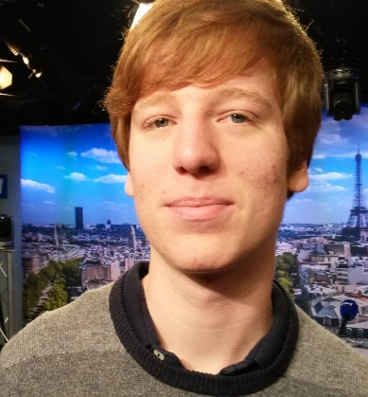
Dimitri
Wyzlic
Software Engineer

Expérience professionnelle et Projets

SEARCHING FOR INTERNSHIP
2016 - 2020 • Computer Engineer • EPITECH
2016 • Machine Learning • Coursera / Stanford
  - Online Machine Learning course by the Baidu creator and certified by Stanford
  - https://www.coursera.org/learn/machine-learning/
2013 -2016• Bachelier • Descartes High School (78)

C ★★★★
Main language used in my School training
Linux, Emacs ★★★★
Used Everyday
Python ★★★
Php / MySQL ★★★
I made a small social network on High School and obtain the highest mark
Ruby ★★
Machine Learning ★
Ongoing training on Coursera

Anglais
Courant (TOEIC : 860)
3 villa Blaise Pascal
92200 Neuilly sur Seine

Tél.
07 62 87 69 58
Email
pro@dimitriwyzlic.com
Github :
github.com/ethanquix
Born the 29/09/97
18 ans
Formation

Compétences

Ski
Every Winter i am going to ski since I am 5

Reading
I read 1-2 book / weeks and I win an reading contest

Area of Interest

September 2011 • ABC Arbitrage • Stage de 3ième
  - Creation of Excel Macros to analyze banking exchange to make automatic buy or sell of stocks
2016 • Epitech• PushSwap (C)
  - Sorting Algorithm inspired by Radix and Fusion Sort method
2016 • Epitech• Wolf3d (C)
  - Video game in fake 3D inspired by Wolfenstein
2016 • Epitech• Minishell (C)
  - Shell inspired by tcsh
2016 • Personnel • Bistromathique (C)
  - Infinite Number Calculator. Got best mark of the year

Skills

Training

Internship / Projects

